To: Dr. Derek Ross

From: Jasey Herrington

Date: November 13, 2024

Subject: Doing the Work Reflection

# Doing the Work

## Introduction

This course, and in turn the group publication project, has been one of the most challenging of my academic career. I believe this is due to several factors, namely balancing a full-time job with my schoolwork, my relative inexperience with Adobe software, and coordinating my group as a first-time managing editor. In this reflection and in my final report, I hope to explore the solutions I discovered surrounding creating a cohesive publication as well as the obstacles I faced. To do this, I will utilize text from our course as well as outside sources I found during the semester.

## Starting a Publication

The next task we were given was to create a publication that we would work on for the entirety of the course. While I have previously taken courses where we divided into groups and created something that was eventually “published” or presented to the class, I have never taken a course that requires you to start from scratch and create a publication on this scale. Typically, I do best when the description for an assignment is presented with all the parameters for success (as in “what you can and cannot do to make an A”). In this case, we were given a lot of creative freedom. While the scope of the project was manageable, I was more concerned with the open-ended nature of the assignment.

As our class brainstormed options for types of publications, I considered our first assigned article from Clem and Cheek. In this reading we discussed how to examine our own perspectives and biases to understand how they influence our editing choices and some best practices for creating a collaborative publication. In the paper, the authors explore the roadblocks that keep the editing industry from expanding its inclusivity practices. This is an important consideration to make as we, novice editors, create a publication. These insights provided our group with a foundation for developing an inclusive mission statement and style guide.

In our first week’s reading, we read Chapter 2 of Technical Editing and began to understand what it takes to create, edit and publish a document. As we read in “Preparing for an Editing Project”, to start the process, we had to “understand the rhetorical situation through and analysis of the communicators and audiences of the document and the contexts of the communication” (Cunningham, et al. 2021).

## Establishing Roles

Separating into groups was easy to do once we understood who was interested in participating in which project. However, establishing our roles within the group proved to be more challenging. I was the one who initially presented the topic and therefore, became the defacto managing editor. I was hopeful, based on our initial conversation in class, that our group would be able to equally share the tasks involved in bringing the idea to fruition.

This was the first learning opportunity for me in this assignment. Initially, we struggled with role clarity, but this experience taught me the importance of establishing clear responsibilities early on. This also meant that our progress on developing the publication was effectively stalled because each group member was not clear about their individual roles.

## Mission Statement

As the originators of *Culinary Chronicles,* it was our responsibility to create a mission statement that could encompass our goals and promises relating to how our editorial team would work to create as inclusive a publication as possible. Due to our disorganization at the beginning, developing the mission statement was limited to the Box folder and external examples. Technology issues also meant that some group members were still struggling to access the Box folder so input on the statement was limited. I still feel that our statement, however concise, provided exactly what we needed to begin developing a comprehensive style guide and editorial process.

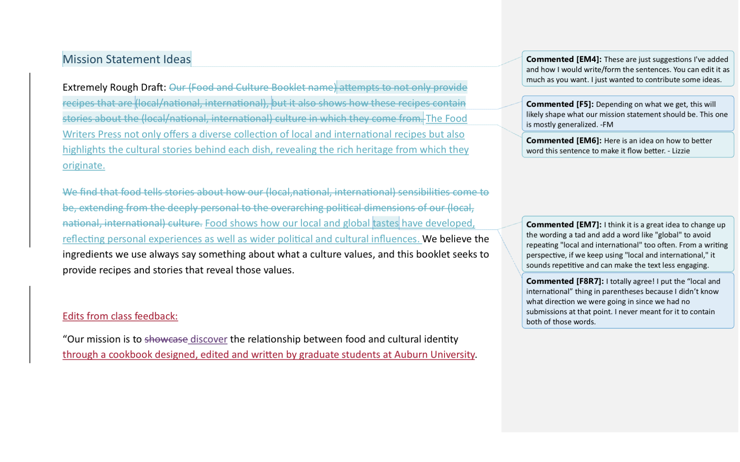

## Style Guide

One of the things I enjoyed most about this course was developing a style guide for our group publication. This aspect of publication development was interesting to me because it allowed us to craft a comprehensive outline of exactly how we wanted our finished product to look, both physically and aesthetically.

In the conclusion of Esha Adhya’s *Key Elements of an Effective Style Guide in the New Age,* they argue that a style guide will be most effective when “it is supported by management, incorporates input from all its beneficiaries, is integrated into the day-to-day operations, and is updated regularly” (Adhya, 2015). Although this guide will cease to be useful at the end of the course, the lessons I learned while developing it will stick with me long after grades are posted.

## Contributor Responses

One of the concerns our group had when planning the cookbook was what would happen if we did not receive enough responses. Initially, the idea was to only have graduate students contribute, but that would have prevented us from receiving all the incredible recipes we received from family and friends outside of higher education.

Thanks to that adjustment, we were able to gather twenty-four total recipes. These recipes ranged from appetizers to drinks to desserts and spanned multiple countries in their influences. Of course, this meant that we had much more to edit than we had originally expected. This division of labor was helped by the “plant group” assisting in our copyediting.

## Creating the “Thing”

Based on our group discussions, I drafted a layout of what each page of our cookbook “should” look like. This draft was especially helpful when beginning to work with InDesign.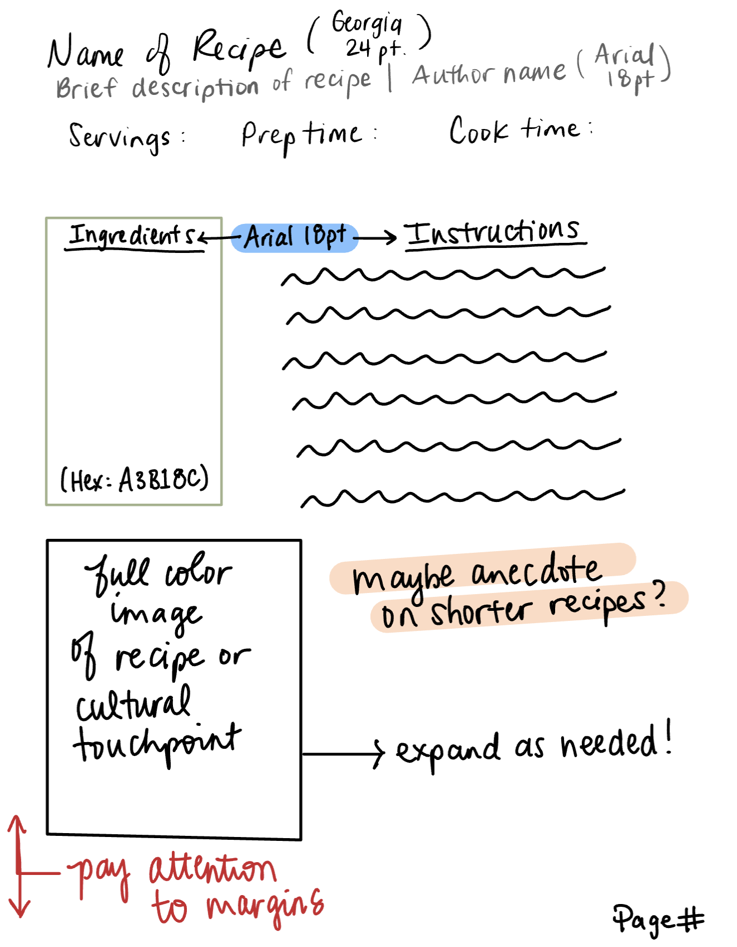

Once I took the InDesign tutorial, I felt confident in adding the shapes needed to create each page. I utilized spreads, shapes, frames and images to craft the structure of our cookbook, which provided a guideline as I began to copy and paste the information into the program. I also tried out some skills not mentioned in the original tutorial, such as creating color schemes in Adobe Color.

Initially, I thought there would be a way for all of us to collaborate on InDesign (as we did in Box), but unfortunately that was not possible, so I worked with my group members to make it possible for them to comment on what needed to be edited. I think that our workshop session in class was especially helpful in getting everyone in our group on the same page.

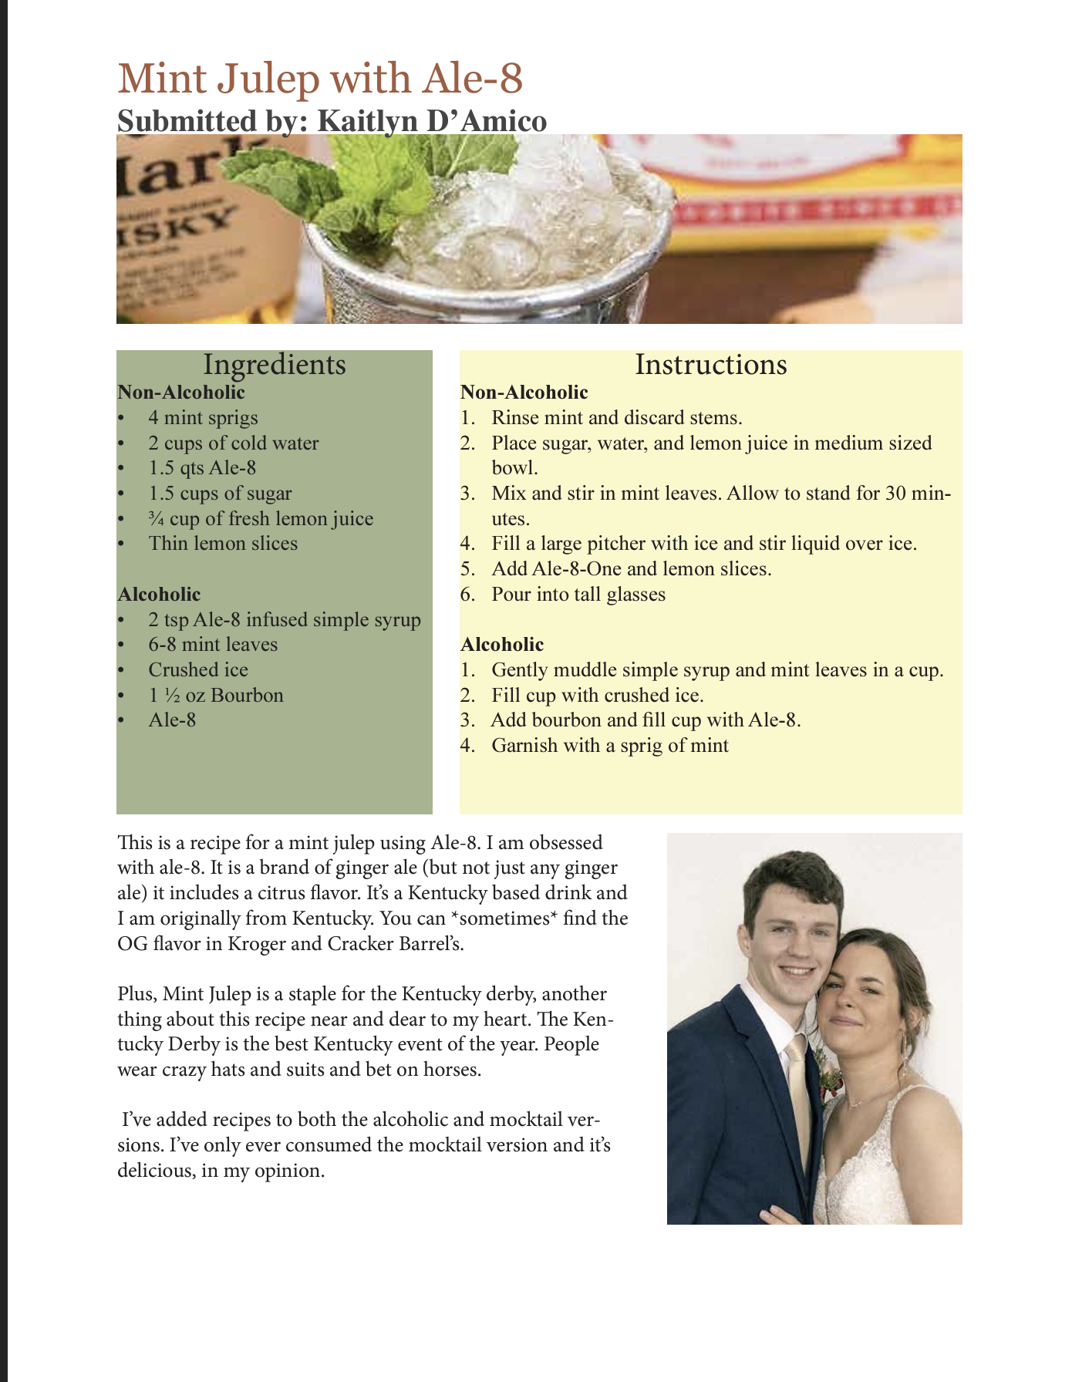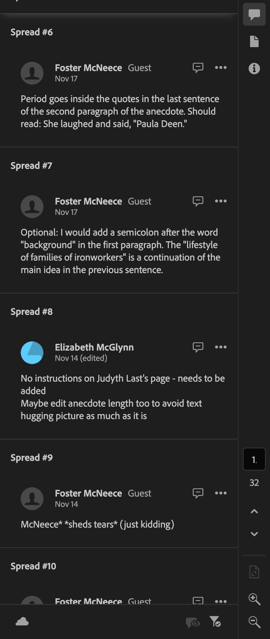

Once the cookbook was created and printed, there were still edits that needed to be made. Eventually I had to take the advice of Dr. Ross that he gave us all the way back in September. I made “things look as consistent as possible, then walk(ed) away”.

## Conclusion

Creating the cookbook was eye opening for me in terms of navigating group dynamics. In Chapters 8 and 9 of *Small Group Communication* by Dr. Jasmine Linabary, she explores how to navigate group conflict and prevent something called “social loafing” which sees group members deciding to contribute less towards group goals for various reasons. There are many ways to mitigate conflict, ranging from more helpful to less helpful. At times, I defaulted to an 'Avoiding' conflict style, which led me to take on extra work. This highlighted the need to develop assertiveness and foster better collaboration, skills I am actively working on.

Though there have been obstacles to succeeding in this course, I truly feel that I have learned more about my own developing editing philosophy than I could have if those obstacles had been otherwise removed. My skills in InDesign have increased dramatically and my editing philosophy has grown to include ideas of accessibility, inclusion, and always incorporating the “imaginary author” in your editing process. Despite initial disorganization, I feel that our team produced a cookbook that is useable and attractive.

## Works Cited

Adhya, E. (2015). Key elements of an effective style guide in the new age. *Technical Communication, 62*(3), 183-192.

Cunningham, C., Malone, M., & Rothschild, J. (2020). *Technical editing: A guide to editing in the workplace*. Oxford Press.

Clem, S., & Cheek, R. (2022). Unjust revisions: A social justice framework for technical  
editing. IEEE Transactions on Professional Communication, 65(1), 135–150.

Linabary, J. (2021). *Small group communication: Forming and sustaining teams.*